Link Trainer Guide- Key points for blood gas training
This document summarises the key points of blood gas testing which should be covered by link trainers during training.
Before testing  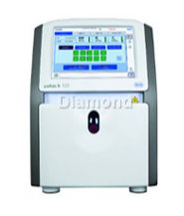 | - Sample should be collected into a dry heparinised syringe or capillary tube.  - Syringe samples should be analysed within 15 minutes of being taken  - Capillaries should be analysed immediately.  - Once the sample has been taken expel any air and cap your sample.  - Label your sample with the correct patient details.  - Roll your sample between your hands and gently invert.  - Check all parameters are green and analyser is in Ready mode
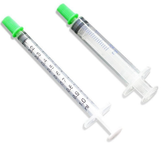  Analysis | - Select correct sample type, capillary or syringe  - Any abnormal results will be highlighted with up/down arrows.  - Measurement of blood bilirubin in patients undergoing phototherapy- Samples are light sensitive and MUST be protected from phototherapy light sources as these are specifically designed to degrade bilirubin and will falsely lower readings in both lab and POCT samples.
After analysis  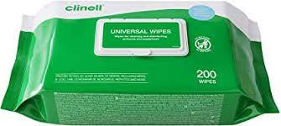 | - Dispose of sample in sharps bin  - Clean any splashes with a Clinell wipe  - Remember to log out before you walk away from the analyser
Troubleshooting   | - Refer to the information sheet near to the gas machine for.  - how to change consumables  - only when consumables have expired. Any other causes will require POCT investigation.  - how/when to run a calibration  - how/when to run a quality control
DO NOT SHARE YOUR OPERATOR ID WITH ANYONE. IT IS A DISCIPLINARY OFFENCE!!

