POCT Link Trainer Guide – tHb

This document summarises the key points which should be covered by link trainers during training of POCT total haemoglobin testing using the Prospect HemoControl

Purpose | - The HemoControl is used to determine the total amount of haemoglobin in whole blood
Sample requirements | - Capillary, venous, or arterial blood may be used  - Sample size is 10µL
Quality Control  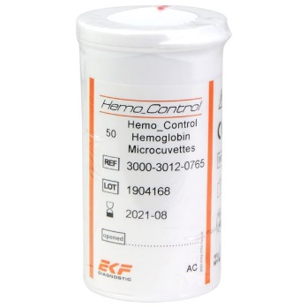  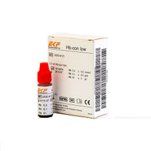 | - Frequency of QC analysis  - Every 24 hours  - Stability of solutions  - Once opened QC is stable at room temperature for 30 days – date on opening  - QC method  - Gently mix QC  - Place 2 drops on hydrophobic surface  - Fill cuvette from second drop  - Wipe off excess  - QC pass / fail  - QC ranges are stated on the packaging (g/L)  - Repeat analysis two more times  - If QC still fails - report to POCT
Patient preparation  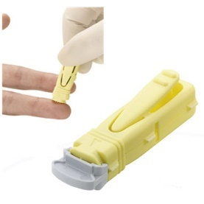 | - Gain positive patient identification and (when possible) consent  - Wear PPE  - Warm the patients hand up  - Drop the patients hand down to the side to let gravity assist with circulation  - ‘Milk’ the palm of the hand to the tip of the finger  - Ensure a deeper sampling lancet is used (a ladybird size blood sample is needed)  - Clean and dry the site for lancing
Analysis    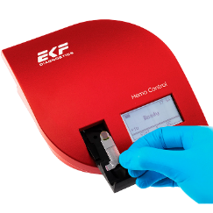 | - Wake analyser by touching screen  - Pull cuvette holder into loading position  - Remove cuvette from tub – do not touch reaction end  - Lance patient finger – wipe away first drop of blood  - Fill cuvette with patient blood in one go – never top up  - Wipe any excess blood off the cuvette and check for air bubbles  - Load cuvette onto holder and push in gently
Results | - Reference ranges  - Adult male 130-180 g/L  - Adult female 115-165 g/L  - Results must be recorded in the patients notes
  After testing | - Dispose of used cuvettes in clinical waste  - The device must be cleaned with a Clinell wipe
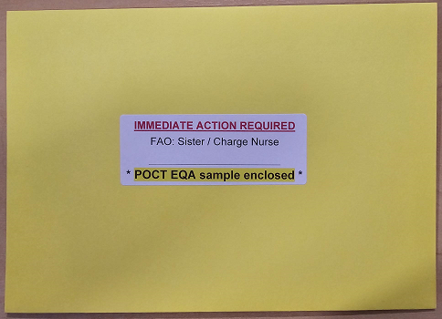EQA samples | - External Quality Assurance is mandatory for all POCT equipment  - Samples are sent every month  - It is every Operator’s responsibility to ensure the EQA samples are run and results returned to POCT
Stock | - Order from POCT  - Do not leave yourself short – order in plenty of time  - QC stock should be kept in the fridge (2-8ºC) until opening
  Analyser issues | - Contact POCT:  - York (772)5890  - Scarborough (771)2659  - Bridlington (771)
* DO NOT SHARE YOUR OPERATOR ID WITH ANYONE *
* IT IS A DISCIPLINARY OFFENCE *

