POCT Link Trainer Guide – Glucose Perfoma training

This document summarises the key points which should be covered by link trainers during training of POCT glucose testing using the Roche AccuChek Performa.

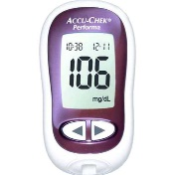  Purpose | - The glucose meter is utilized to measure glucose levels in blood samples.
Before using the meter | - Check the meter is showing the correct time and date (including year).  - Analyse both levels of QC (once the result is on screen press the > button to highlight level 1 or 2, then press the on/off button. This will commit the results to the meters memory).  - Document QC results in the logbook.
Quality Control / EQA | - Two levels of QC must be analysed everyday the meter is used, if patient results given by the meter are unexpected or the meter has been dropped/damaged.  - If a QC fails, try the following:  - Gently invert the liquid QC and ensure the correct level is being used.  - If that fails, try new QC liquids.  - If that fails, try a new pot of strips.  - If all the above fail, please contact the POCT team.  - EQA samples should be tested on receipt, and the results returned to POCT on the form provided ASAP.
  Patient / sample preparation | - A fresh capillary or venous sample is required.  - Gain positive patient identification and (when possible) consent.  - Wear the appropriate PPE.  - Wash and dry the patient’s hand thoroughly using warm water / soap warm water, NOT alcohol wipes/gel.  - Lance the finger on the side of the pad, no lower than the nail bed, then gently massage along the finger to obtain a blood drop. Do not squeeze the finger.
Analysis | - Ensure the code number shown on chip insertion matches code on the strip pot.  - Measuring range = 0.6-33.3 mmol/L.
Results | - Results are displayed on the screen after analysis has been completed.  - Record the results in the patient notes.
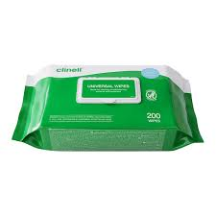  After testing | - Dispose of test strips and lancets following waste management guidance.  - The analyser can be cleaned with Clinell wipes after each use.
Stock | - Test strips and QC liquids are ordered from pharmacy.  - Replacement batteries and logbooks should be obtained from POCT via your Hub Admin Teams.
  Analyser issues | - Contact POCT:  - York (772)5890  - Scarborough (771)2659  - Bridlington (771) 3321
* DO NOT SHARE YOUR OPERATOR ID WITH ANYONE *
* IT IS A DISCIPLINARY OFFENCE *

