POCT Link Trainer Guide – iSTAT alinity training

This document summarises the key points which should be covered by link trainers during training of POCT blood gas analysis using the Abbott iSTAT Alinity.

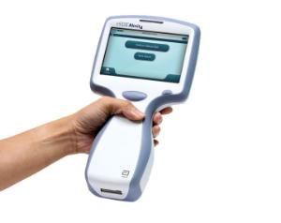  Purpose | - The iSTAT alinity measures pH, blood gases, electrolytes, co-oximetry, glucose, and lactate.  - It aids in diagnosing and managing medical conditions by providing rapid analysis of acid-base balance, oxygenation, and electrolyte levels.
Sample requirements | - Sample volume = 65uL.  - Venous or arterial whole blood should be taken in a dry, balanced heparin blood gas syringe or capillary tube (fill cartridge within 10 minutes of collection).  - Venous samples can also be collected in a lithium heparin tube (fill cartridge within 10 minutes of collection).  - Capillary whole blood should be taken in a balanced heparin capillary tube (fill cartridge immediately after collection).  - When using CG4+ cartridges for blood gas and lactate the cartridge MUST be filled immediately.  - Label samples with patient details.
Quality Control | - QCs and electronic stimulator checks are performed by the POCT team at the beginning of every month.
  Patient / sample preparation | - Gain positive patient identification and (when possible) consent.  - Wear the appropriate PPE.  - Obtain samples described in the ‘sample requirements’ section.
Analysis | - Ensure the test cartridge has been at room temp for at least 5 minutes prior to use.  - Select ‘perform patient test’ and then scan your operator ID when prompted.  - Enter the patient NHS number.  - Scan the barcode on the cartridge pouch then choose the sample type (venous/capillary/arterial).  - Follow the instructions on the screen to fill the cartridge, close it and then insert it into the machine.  - The test will run and then prompt you once finished.
Results | - Results are displayed on the screen after analysis has been completed. They can also be found by: More Options > Review Results > All Results.  - Results can be printed by holding the machine in front of the printer and pressing ‘print’.  - Results are automatically transferred to patient records. Record results in patient notes.
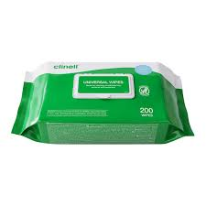  After testing | - Dispose of test cartridges following waste management guidance.  - The analyser can be cleaned with Clinell wipes – avoid liquid entering the cartridge port, metal pins under the barcode reader, gold contacts on the underside of the battery.
Stock | - Test cartridges and printer paper are provided by the POCT team.
  Analyser issues | - Contact POCT:  - York (772)5890  - Scarborough (771)2659  - Bridlington (771) 3321
* DO NOT SHARE YOUR OPERATOR ID WITH ANYONE *
* IT IS A DISCIPLINARY OFFENCE *

