POCT Link Trainer Guide – HIV test training

This document summarises the key points which should be covered by link trainers during training of HIV testing using the Abbott Determine HIV Early Detect POCT test.

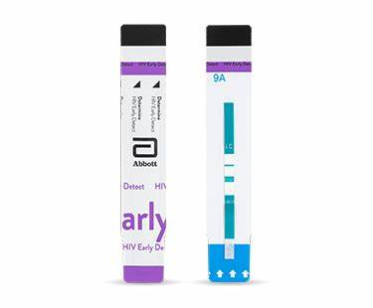  Purpose | - The Abbott Determine HIV Early Detect test designed to detect the presence of Antibodies (Ab) to HIV-1 or HIV-2, as well as non-immunocomplexed (free) HIV-1 p24 Antigen (Ag).  - A reactive result on either the antibody or antigen component, or on both simultaneously, indicates a suggestive indication of HIV infection.
Sample requirements | - 50ul is required to fill the test strip.  - Finger prick whole blood capillary samples should be analysed immediately.  - Venous/capillary whole blood taken into EDTA labelled with patient details can be stored at 2-8°C for 7 days before use.  - Serum/plasma labelled with patient details can be stored at 2-8°C for 7 days or at -20°c or below after 7 days but AVOID freeze/thaw cycles.  - Samples must be at room temperature before use.
EQA | - EQA samples should be tested on receipt, and the results returned to POCT on the form provided ASAP.
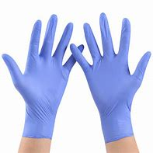  Patient / sample preparation | - Gain positive patient identification and (when possible) consent.  - Wear the appropriate PPE.  - Clean patients’ hand/finger with alcohol and allow to dry.
Analysis | - Ensure samples have come to room temperature prior to analysis and are thoroughly mixed.  - Remove the protective foil seal from the strip (strip must be used within 30 minutes of removal).  - Use a single use lancet to puncture the finger. Wipe away the first drop of blood with sterile gauze and massage the finger to obtain a second drop of blood.  For whole blood capillary using EDTA capillaries:  - Touch the tip of the EDTA capillary tube to the drop of blood – avoiding air bubbles.  - Fill the tube with blood between the 2 marked lines.  - Place the capillary tube containing the blood sample into the HIV strip sample pad, allowing all blood to transfer before lifting the capillary away to prevent bubble formation.  - Immediately apply 1 drop of Chase Buffer to the sample pad then wait a minimum of 20 minutes from addition of sample (up to 40 minutes) and read the result.  For serum/plasma samples:  - Apply 50uL of sample to the sample pad marked by the arrow.  - Wait a minimum of 20 minutes from addition of sample (up to 40 minutes) and read the result.
Results | - To interpret the results please ensure that you are in good light.  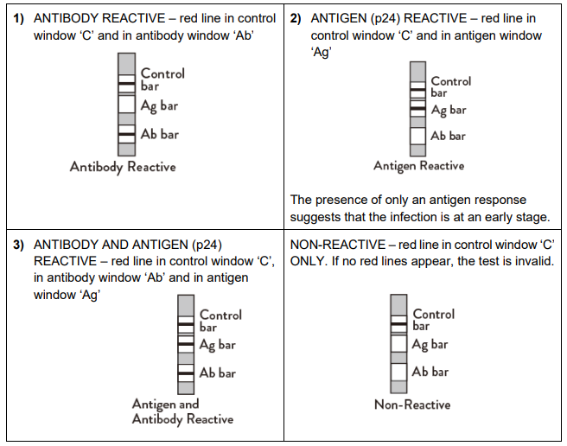  - There MUST be a control line visible, or the results are invalid and cannot be reported.  - Record result in the patients’ sexual health hospital notes, signed by both members of staff who read the test. All reactive results must be relayed to a member of the HIV team.  - Confirmatory tests should be sent to the microbiology laboratory with a request form with:  - Result, kit lot number and expiry of POC HIV test written on the form.  - Mark samples as urgent if POC HIV = reactive, mark samples as routine if POC HIV = non-reactive.  - Needle phobic patients may deny laboratory confirmation if POC HIV results were non-reactive, but all reactive results MUST be confirmed with the microbiology lab.
After testing | - Inform patient of the POC HIV test result and that confirmation a venous sample has been sent to the lab which can take 7-10 days, if the result was reactive inform patient that there is rate of approximately 1% of false reactive results on a POC HIV test.  - Dispose of the sample, capillary and test strips following waste management guidance.
Stock | - Tests and chase buffer are provided by the POCT team.
  Analyser issues | - Contact POCT:  - York (772)5890  - Scarborough (771)2659  - Bridlington (771) 3321
* DO NOT SHARE YOUR OPERATOR ID WITH ANYONE *
* IT IS A DISCIPLINARY OFFENCE *

