POCT Link Trainer Guide – Atellica DCA HbA1c training

This document summarises the key points which should be covered by link trainers during training of POCT HbA1c testing using the Atellica DCA analyser.

Sample requirements | - 1µL fresh capillary whole blood or anticoagulated venous whole blood (EDTA, heparin, or citrate).  - Capillary samples must be analysed immediately.
Quality Control / EQA | - EQA samples should be tested on receipt, and the results returned on the form provided to the POCT team ASAP.  - Two levels of liquid QCs (normal and abnormal) are required every day the machine is used for patient testing.  - When running a QC, ensure the LOT number you select on the analyser matches up with the LOT number on the QC bottles you are using. If they do not match, add the new QC onto the analyser by scanning the QR code on the card provided in the QC box.
  Patient / sample preparation | - Gain positive patient identification and (when possible) consent.  - Wash and dry the patient’s hand thoroughly.  - Lance the finger and gently massage from the base of the finger to obtain a good blood drop. If the blood smears or runs, wipe it off with a tissue and gently squeeze another round drop of blood.  - Touch the capillary holder onto the blood droplet until it is full, ensure there are no gaps or air bubbles.
Analysis  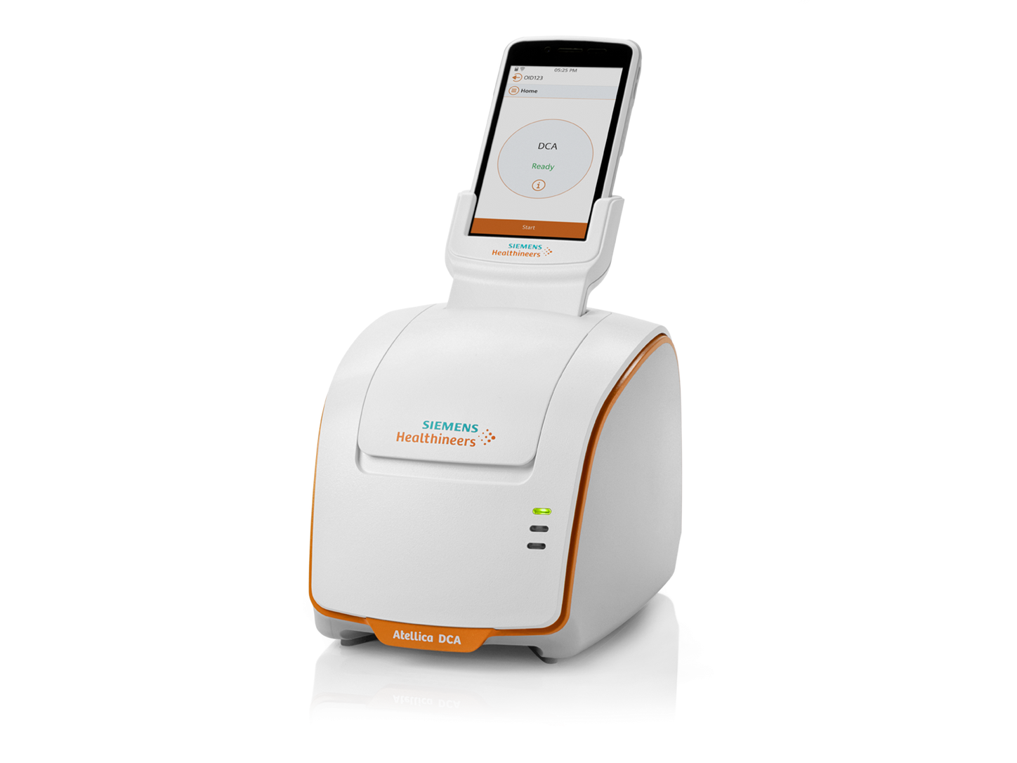 | - Ensure test cartridge is at room temperature before testing.  - Collect patient sample, remove any excess sample by wiping end of capillary tube on inside of foil pouch.  - Insert the filled capillary into the test cartridge until it snaps in place.  - Place the test cartridge into the machine and remove the foil tab, then close the door immediately.  - Enter patient details when prompted (NHS number, name, DOB).
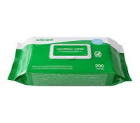  After testing | - Dispose of test cassettes into your clinical waste bin.  - The analyser can be cleaned with Clinell or 70% isopropyl wipes.
Stock | - Atellica DCA test capillaries, test cartridges and QC liquid are provided by the POCT team.  - Control solutions should be stored in the fridge and are valid 30 days from opening.  - Test cartridges stored in the fridge are valid until the expiry date, those at room temperature are only valid for 60 days.
  Analyser issues | - Contact POCT:  - York (772)5890  - Scarborough (771)2659
DO NOT SHARE YOUR OPERATOR ID WITH ANYONE
** IT IS A DISCIPLINARY OFFENCE**

