POCT Link Trainer Guide – INR

This document summarises the key points which should be covered by link trainers during training of POCT INR testing using the Roche Coaguchek Pro II
Purpose | - The Coaguchek is used to determine blood INR  - ONLY TO BE USED ON PATIENTS RECEIVING TREATMENT WITH WARFARIN
Sample requirements | - Capillary, venous, or arterial blood may be used  - Sample size is 8µL
Quality Control  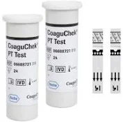  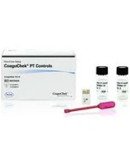 | - Stability of QC solutions  - QC is made up fresh every time  - Sample is stable for 30 minutes, after which it must be discarded  - Frequency of QC analysis  - One QC level every 24 hours meter is in use  - Minimum of once per week if not in use  - Alternate level 1 and 2 QC  - Ensure QC has been left to stand at room temperature for 5 minutes before and after reconstituting  - If QC fails  - Try a fresh vial of QC  - Contact POCT
Patient preparation  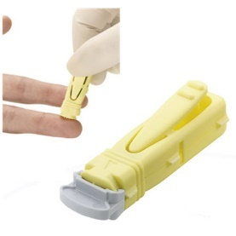 | - Gain positive patient identification and (when possible) consent  - Wear PPE  - Warm the patients hand up  - Drop the patients hand down to the side to let gravity assist with circulation  - ‘Milk’ the palm of the hand to the tip of the finger  - Ensure a deeper sampling lancet is used (a ladybird size blood sample is needed)  - Clean and dry the site for lancing
Analysis  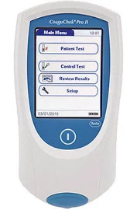 | - Method  - Log onto meter using Operator ID and passcode  - Select ‘Patient Test’  - Choose patient from list or enter NHS number  - Insert strip and wait until prompted to apply blood sample  - Measuring range  - 0.8 - 8.0
Results | - INR critical range = >4.5  - Send a sample to the lab to be analysed  - Results with symbols < (less than) or > (more than) should be rechecked  - Results must be recorded in the patient notes
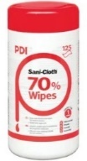  After testing | - Dispose of test strip in clinical waste  - The device must be cleaned with an alcohol wipe such as 70% isopropanol Sani-cloth.
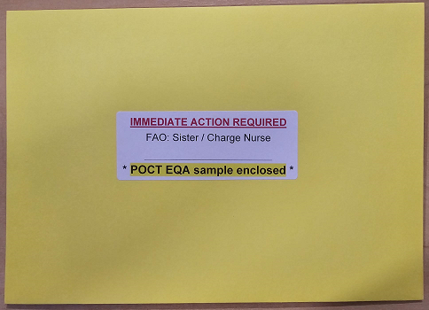EQA samples | - External Quality Assurance is mandatory for all POCT equipment  - Samples are sent every 3 months  - It is every Operator’s responsibility to ensure the EQA samples are run and results returned to POCT
Stock | - Order from POCT  - Do not leave yourself short – order in plenty of time  - QC should be kept in the fridge (2-8ºC)  - Strips can be stored at room temperature
  Analyser issues | - Contact POCT:  - York (772)5890  - Scarborough (771)2659  - Bridlington (771)
* DO NOT SHARE YOUR OPERATOR ID WITH ANYONE *
* IT IS A DISCIPLINARY OFFENCE *

